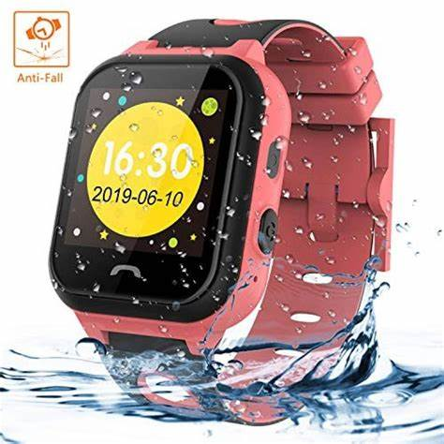**Themoemoe**

Description: Themoemoeis a global technology brand that initially started as a sub-brand of Huawei before becoming an independent company in 2020. It is known for producing smartphones, laptops, wearables, and other consumer electronics, aiming to provide innovative, high-quality products at competitive prices. Honor smartphones are especially popular for their sleek designs, powerful performance, and advanced camera features, catering to both budget-conscious and premium users. Beyond smartphones, Honor has expanded its product lineup to include smartwatches, fitness trackers, tablets, and laptops, making it a versatile player in the tech market. The brand focuses on blending technology with style and user experience, appealing to a broad audience with modern, functional devices. is a global technology brand that initially started as a sub-brand of Huawei before becoming an independent company in 2020. It is known for producing smartphones, laptops, wearables, and other consumer electronics, aiming to provide innovative, high-quality products at competitive prices. Honor smartphones are especially popular for their sleek designs, powerful performance, and advanced camera features, catering to both budget-conscious and premium users. Beyond smartphones, Honor has expanded its product lineup to include smartwatches, fitness trackers, tablets, and laptops, making it a versatile player in the tech market. The brand focuses on blending technology with style and user experience, appealing to a broad audience with modern, functional devices.